All Business Summary April 2001 (March Production)

Settlements Headcount Versus Plan

Staffing Headlines - April

- Ray Dollman, UK Power, left Enron. Recruitment for replacement underway.
- Anthony Smith (Admin) joined UK Power.
- Two offers made (1 Admin, 1 Snr Spec for Stephen Bell’s team) and accepted. Start dates TBA.
- Recruitment drive continues: approx 5 interviews per week for the team.

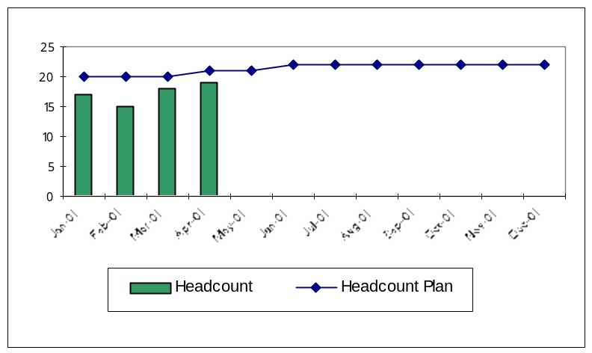

Recruitment, Retention, Attrition & Experience Statistics

 | Jan | Feb | Mar | Apr | May | Jun | Jul | Aug | Sep | Oct | Nov | Dec
Initial Headcount | 17 | 17 | 15 | 18
Leavers – Enron Commercial |  | (1)
Leavers – Enron non-Commercial |  |  | (3)
Leavers – Management initiated |  | (2) |  | (1)
Leavers – Voluntary other
New Joiners – from within Enron
New Joiners – external new hires |  | 1 | 4 | 1
Temporary Staff |  |  | 2 | 1
Final Headcount | 17 | 15 | 18 | 19
Average Experience (months) | 9.7 | 9.8 | 8.0 | 8.1

Volume Statistics

Other Headlines - April
 | Mar | April
Avg Hours Overtime | 34 | 42 | ■ R
# Counterparties | tbd | tbd | ■ B
Settlement error rate | tbd | tbd | ■ B
Attrition | 20% | 5% | ■ G
Avg Experience (mo) | 8.0 | 8.1 | ■ R

Trigger Levels
 | ■ R | ■ Y | ■ G
Overtime | >40 | >20 | <=20
# Counterparties | tbd | tbd | tbd
Error rate | tbd | tbd | tbd
Attrition | >20% | >10% | <=10%
Avg Experience | <10 | <12 | >=12

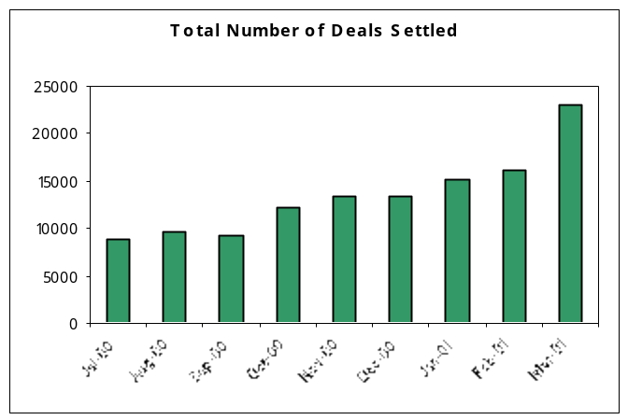

2001 Project status & Commentary

Structured deal handover to CM | ■ | On target. R&Rs to be documented.
NETA Implementation | ■ | UAT not completed. Daily reporting implemented
Accrual / Credit Process | ■ | Not yet started. Awaiting Trade Accounting resources.
Daily Settlements team set-up | ■ | Awaiting additional resources
Envoice Implementation | ■ | Gas implementation delayed to May invoicing due to Operational risks during NETA
Cash Management | ■ | Review of changes made in TWS - Ongoing
VAT Re-engineering | ■ | Not yet started. Awaiting VAT resource.

UK Gas- April 2001 (March Production)

Volumes / Error Information

 | Physical | Structured | Options | Financial | Brokerage
Total Number of Settled Deals | 5375 | 17 | 156 | 130 | 121
Settlements Errors | 0 | 3 | No data | 0 | 0
Other errors/issues | 0 | 0 | No data | 0 | 0
Error rate | 0.0% | 12% | 0.0% | 0.0% | 0.0%
Interest Claims against Enron ($ amount) | 0 | 0 | 0 | 0 | 0
Interest Claims by Enron | 0 | 0 | 0 | 0 | 0
Manual Payments | 1 | 0 | 1 | 0 | 0

Commentary – Errors

No | Type | Commentary | Counterparty
2 | Settlements | Failure to fax two invoices – settlement still received/paid in timely fashion. | Bristol Energy/Enrici
* | Brokerage | Brokerage is up-to-date apart from some outstanding Prebon queries. | Various
1 | Settlements | Failure to release payment from SAP. Interest will be charged by CP under Network Code rules. Approx £5. | Transco

Commentary – Manual Payments

No | Cause | Commentary | Counterparty
1 | Systems | LOM-SAP interface failure. | Alliance Gas
1 | (Systems) | Return of funds to CP. | TotalFina Elf

Volume Trends
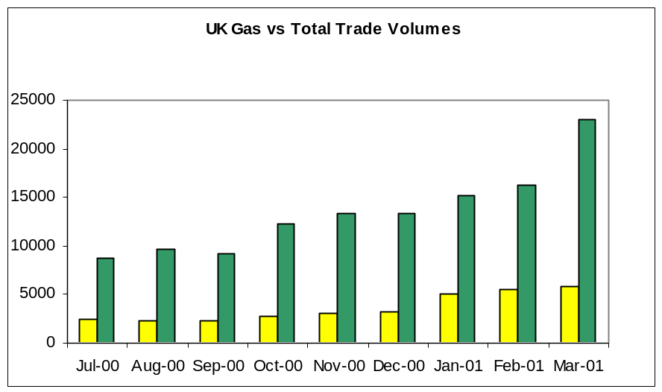

Management Highlights

- Envoice: Settlements sign-off on EnVoice UAT, but delay implementation due to NETA resourcing issues. EnVoice will launch with April production invoicing cycle. There have been further enhancements and these will be UAT week commencing 23rd April 2001.
- “Missing deals” – a new process for managing these missing deals has been proposed by Grace Hagan to ensure accurate & complete capture, preventing additional work downstream and upstream re-work. Commercial, Risk, Docs & Settlements to discuss.
- Defined Roles & Responsibilities: Settlements to produce a document detailing the roles, responsibilities & time frames required between Contract Management and Settlements for the contracts recently handed over.

UK Power- April 2001 (March Production)

Volumes / Error Information

 | Physical | Structured | Options | EFA | Brokerage
Total Number of Settled Deals | 2673 | 5 | 10 | 4387 | tbd
Other errors/issues | $ | 1 | 0 | * | tbd
Settlement errors | $ | 0 | 0 | * + 1 | tbd
Error rate | $ | 20% | 0 | * | tbd
Interest Claims against Enron ($ amount) | 0 | 0 | 0 | 0 | 0
Interest Claims by Enron | 0 | 0 | 0 | 0 | 0
Manual Payments | 1 | 0 | 0 | 3 | 0

Commentary – Errors

No | Type | Commentary | Counterparty
$ | Commercial/  IT/Risk | Physicals deals were difficult to reconcile with CPs. A number of deals required updating in our FO systems- incorrect settlement frequency or strike price. Deal flipper did not complete the migration of deals completely. | Various
* | IT/Risk/  Commercial/  Settlements | BOSS team were unable to effect a systems fix to import the last hour of EFA, attached in EnPower to the physical deals. EFAs were invoiced & logged manually. Settlements continue to work with TA to overcome some reconciliation issues. Clock change issues also. | Various
3 | Risk | Risk failed to provide a correct DOVE report for reconciliation purposes in a timely fashion. | All
1 | Settlements | Failure to resolve issues & pay CP in timely fashion. | Magnox
1 | Settlements | Settlements failed to complete Watershed requirements in timely fashion. | ETOL

Commentary – Manual Payments

No | Cause | Commentary | Counterparty
4 | Time | Last minute resolution of large numbers of issues, meant that payments were made manually where the interface to TWS was missed. | Various

Volume Trends
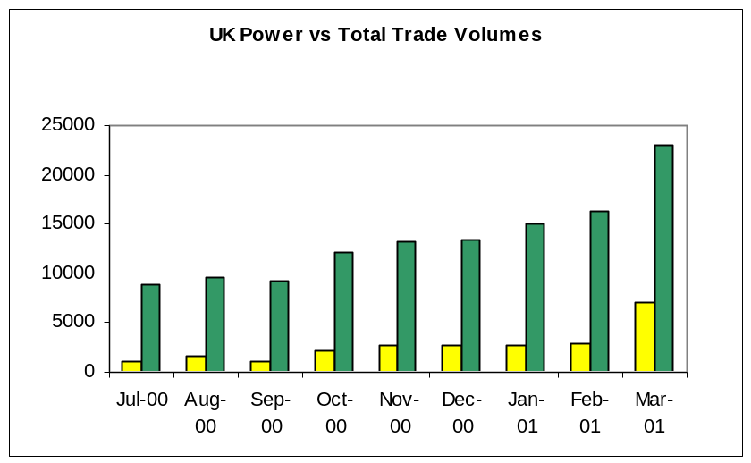

Management Highlights

- Deal flipper: IT solution did not appropriately allow differentiation between financial & physical deals @ NETA go-live for Settlement purposes. Physical settlement blocked out 23hrs – 00hrs timeslots. For financial settlements the hour was unable to be added back on appropriately. Issues also with clock change hour and data remaining in EnPower. PPP finals were not loaded to EnPower in a timely fashion by IT FO support. As a result manual invoicing was performed for 4387 deals (32 counterparties) and Settlements &TA continue to work on clean-up.
- Systems: no Settlements systems were able to be UAT prior to use in live environment due to development delay as Commercial negotiations continued.
- Staffing Issues: Ray Dollman was managed out of Enron. Replacement recruiting effort underway.

Continental Gas- April 2001 (March Production)

Volumes / Error Information

 | Physical | Options | Financial | Brokerage
Total Number of Settled Deals | 738 | 0 | 0 | *
Settlement errors | 1 | 0 | 0 | *
Other errors/issues | 5 | 0 | 0 | *
Error rate | 0.14% | 0.0% | 0.0% | *
Interest Claims against Enron ($ amount) | 0 | 0 | 0 | 0
Interest Claims by Enron | 0 | 0 | 0 | 0
Manual Payments | 1 | 0 | 0 | 0

Commentary – Errors

No | Type | Commentary | Counterparty
1 | Settlements | Invoice faxed to wrong CP | Epon
5 | Trading | Deals not entered into Risk Management system. | Various

Commentary – Manual Payments

No | Cause | Commentary | Counterparty
1 | Systems | LOM-SAP interface failure | Eon

Volume Trends
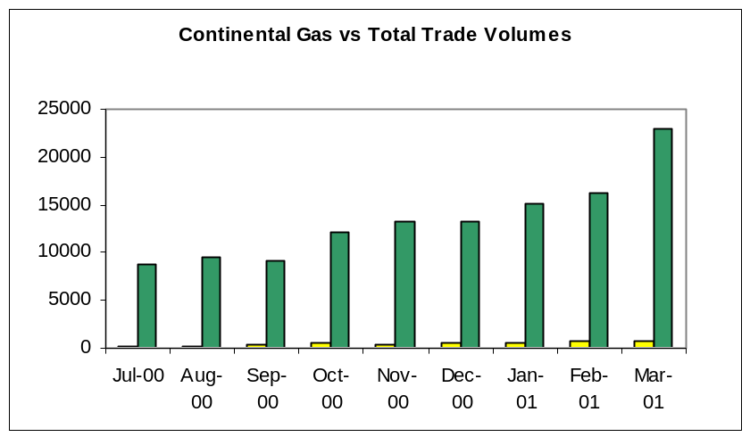

Management Highlights

- Entrade Deals: All historical Entrade deals have been settled with Essent, as per letter & authorisation from David Gallagher.
- Alliance Gas: Alliance Gas (Feb production) deals have not yet been resolved with the CP. They requested that we delay payment for five days.
- Static Data review: completed in time for EnVoice implementation.
- Gas Transportation: process review completed. Recommendations implemented.

Continental Power- April 2001 (March Production)

Volumes / Error Information

 | Physical | Financial | Options | Brokerage
Total Number of Settled Deals | 9182 | 136 | 53 | *
Settlement errors | 0 | 0 | 0 | *
Other issues/errors | 7 | 0 | 0 | *
Error rate | 0.0% | 0.0% | 0.0% | *
Interest Claims against Enron ($ amount) | 1 | 0 | 0 | 0
Interest Claims by Enron | 0 | 0 | 0 | 0
Manual Payments | 15 | 0 | 0 | 0

Commentary – Errors

No | Type | Commentary | Counterparty
1 | Systems | Volume discrepancies between FO & BO systems on structured options. | Various
6 | Commerical | Incorrect volume/currency booked in Risk Management system | Various

Commentary – Manual Payments

No | Cause | Commentary | Counterparty
12 | Systems | Payments cannot be made through SAP | EEX
1 | GCP | Awaiting bank detail set up in GCP. | TXU
2 | Systems | LOM-SAP interface failure. | Unknown

Volume Trends
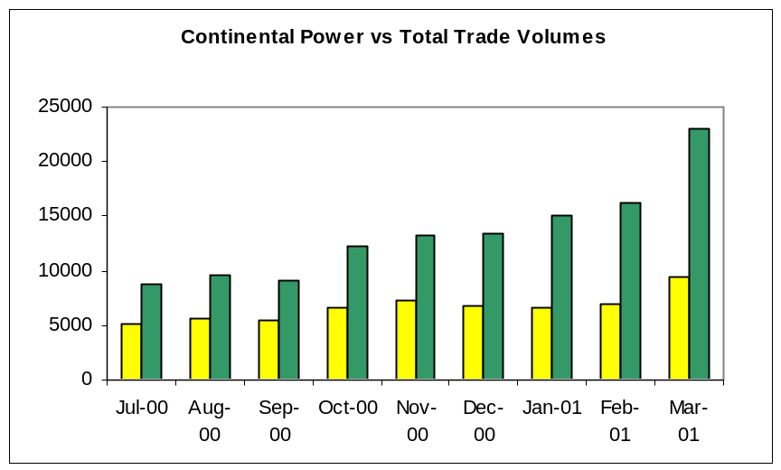

Management Highlights

- Options invoicing: New process implemented to streamline option invoicing. Affirmation of bank details, value & value date are completed on T+1 irrespective of buy/sell.
- Structured Options: On-going difficulties experienced by Settlements as volumes in FO systems does not match volumes in BO systems. IT are aware and investigation is underway.

